**Ann Dinh**

**Anjali Nepal**

**Kaustubh Gawande**

**Swathi Manjunatha**

**Swikriti Bhattarai**

**Professor RamaKrishna Koganti**

**INSY 5373-001**

**21 April 2024**

**SAMS: Smart Agriculture Monitoring System**

**1. INITIATION**

**INTRODUCTION**

**Smart Agriculture Monitoring System (SAMS) revolutionizes traditional farming** **practices by integrating cutting-edge technology to optimize crop cultivation, enhance** **yield, and mitigate risks. SAMS revolutionizes traditional farming practices by** **integrating advanced sensor technologies, data analytics, and machine learning** **algorithms to optimize crop management and enhance agricultural productivity. By** **continuously monitoring key environmental parameters such as soil moisture,** **temperature, humidity, and crop health, this innovative system empowers farmers to** **make data-driven decisions in real time, enabling precise irrigation, fertilization, and** **pest control strategies. Through predictive analytics and remote monitoring** **capabilities, SAMS not only maximizes crop yields but also promotes sustainable** **farming practices, ensuring efficient resource utilization and environmental** **stewardship.**

**2. PLANNING**

**BUSINESS PROBLEM**

**The agricultural sector faces significant challenges including inefficient resource** **utilization, unpredictable weather conditions, and the increasing demand for food** **production amidst a growing global population. Traditional farming methods often lack** **precision and fail to adapt to changing environmental factors, leading to reduced** **yields, higher costs, and environmental degradation. Addressing these challenges** **requires innovative solutions that enable farmers to optimize resource management,** **mitigate risks, and improve productivity while ensuring sustainability and profitability in** **agricultural operations.**

**ROI/IRR/PAYBACK**  
 **SAMS project's financial projections reveal a promising** **outlook over its 5-year lifespan. With an initial investment of $500,000 and annual** **operating costs of $20,000, SAMS is projected to generate substantial revenue. Year 1** **anticipates revenue of $100,000, while subsequent years see a 20% increase. The net** **cash flows reflect a net loss of $120,000 in the first year, followed by positive returns in** **the subsequent years, totaling $444,160 in net profit over the 5 years. The Return on** **Investment (ROI) stands at an impressive 222.08%. The Internal Rate of Return (IRR)** **and Payback Period are also positive, indicating a profitable venture. With a payback** **period of approximately 2.16 years, the financial analysis indicates that SAMS is a** **sound investment with a promising return.**

**COST ANALYSIS**

**The Smart Agriculture Monitoring System project encompasses various cost** **components, with hardware procurement (sensors, communication modules)** **estimated at $30,000, software development (firmware, cloud platform) at $230,000,** **machine learning model development at $150,000,, integration and testing at 70,000,** **pilot deployment (installation, training) at $10,000, operational expenses (maintenance,** **cloud usage) at $50,000, and miscellaneous costs (contingency, legal) at $40,000. The** **total project cost is estimated to be around $570,000.**

**SWOT ANALYSIS**

**SAMS excels in increasing resistance to climate change through technological** **innovation, improving production, and optimizing resource efficiency. High starting** **costs, technical complexity, and worries about connectivity and data protection are** **some of the difficulties, though. Growth in the market, collaborations, policy support,** **and scalability are all opportunities for SAMS. However, the risks like technical risks,** **regulatory costs, opposition to change, and market competition can be more** **prominent. Adoption and successful implementation in agriculture need strategic** **navigation of these issues.**

**WORK BREAKDOWN STRUCTURE (WBS)**

**WBS offers an organized summary of all the actions and activities needed to create,** **implement, and manage the SAMS project. To help with project planning,** **implementation, and oversight, each component was further divided into distinct tasks** **and subtasks which helps in the ease of project execution and closure as shown in** **Figure 2 below.**

**Figure 2: Work Breakdown Structure (WBS) for SAMS**

**COMMUNICATION PLAN**

**To effectively convey messages and information throughout the project to the** **stakeholders, communication plan is created which is given below:**

|  |  |  |  |  |  |
| --- | --- | --- | --- | --- | --- |
| **Communication Objective** | Stakeholders | Key Messages | Communication Channels | Responsible Parties | Time |
| **Raise awareness about SAMS** | Farmers | **Improved crop productivity, Technological innovation** | **Workshops and training sessions** | Project Manager | **Mid and end of the project** |
|  |  | **Resource efficiency, Resilience to climate change** | **Farmer outreach events like agricultural fairs and exhibition** |  |  |
| **Promote partnerships & collaboration** | **Agricultural technology** | Collaboration opportunities | **Industry conferences and forums** | Project Manager | **Throughout and after the project** |
|  | Providers | Value of joint innovation | Webinars |  |  |
| Clear & Consistent Communication | Project Team | Introduction to SAMS and its benefits | Regular Team Meetings | Project Manager | Throughout the project |
|  | Farmers | Compliance with agricultural regulations | Project Documentation | Marketing Team | After the project |
|  | **Project Investors & Sponsors** | **Benefits of SAMS** | **Reports and Email Updates** | Project Manager | Throughout the project |
| Team Meetings | Project Manager | Introduction to SAMS and its benefits | Regular Team Meetings | Project Manager | Throughout and weekly |
| Email Updates | **Investors, Project** Team, Project Manager | Project Progress **and milestones** | Email Updates | Project Manager | Throughout and weekly |
| App Development Updates | Project Team, Developers | **Application development & Updates** | **Email Updates, Team Meetings** | **Project Lead, Design & Development Team** | Throughout and weekly |
| **Social Media Promotion** | Marketing Team | **Marketing and** Promotion strategies | **Social Media Platforms** | **Marketing Team, Project Lead** | **Towards the end and after the project** |

**Table 1: Communication Plan for SAMS**

**RESPONSIBILITY MATRIX**

**The responsibility matrix for SAMS clearly assigns roles and tasks, enhancing clarity** **and accountability, as seen in Figure 3. For example, assigning a hardware engineer** **to develop IoT sensors ensures precision, avoiding potential errors from less qualified** **personnel like project managers. This prevents overlap in the tasks and improves team** **communication and collaboration, essential for successful project execution.**

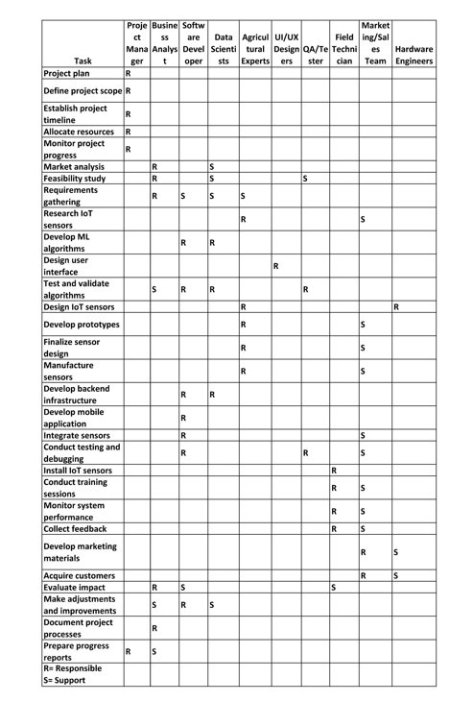

**Figure 3: Responsibility Matrix for SAMS**

**NETWORK DIAGRAM**

**To assist in planning SAMS’s execution, a network diagram was made. As shown in** **Figure 4, the diagram shows a list of events that need to take place within this project** **and their early/late start and end dates. Moreover, when looking at the last five events,** **it is evident that the Development phase will take the longest time to complete. It is** **important that this step has lots of focus to ensure proper preparation for the success** **of the Test & Quality Assurance process. Overall, the network diagram aids the project** **in creating a clear overview of task scheduling, thus, allowing each project phase to be** **efficiently planned for execution.**

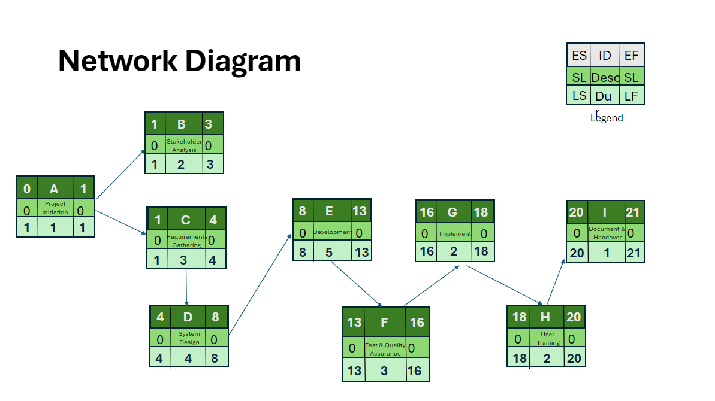

**Figure 4: Network Diagram for SAMS**

**PROJECT SCHEDULE**

**The SAMS project, running from May 18, 2022, to May 21, 2024, comprises four** **distinct phases. Phase 1 (May 18, 2022 - July 17, 2022) focuses on defining the** **project scope, outlining tasks, and establishing timelines. Phase 2 (July 18, 2022 -** **October 3, 2023) involves detailed planning, resource allocation, and finalizing** **dependencies to streamline project execution. Phase 3 (April 16, 2024 - May 13, 2024)** **marks the execution phase, where tasks like IoT sensor development, machine** **learning algorithm creation, and app development are actively undertaken. Finally,** **Phase 4 (May 14, 2024 - May 21, 2024) is dedicated to project closure, encompassing** **final testing, user training, and the official product launch.**

**GANTT CHART**

**A Gantt chart (Figure 5) visually maps out tasks in project management. For SAMS, it** **starts with Market Analysis for 3 weeks, guiding the 5-week Technology Research. IoT** **Sensor Development and App Development overlap, crucial for integration. Testing,** **System Integration, Pilot Testing, Training, and Launch Preparation follow, culminating** **in a Product Launch after 2 years. The Gantt chart manages task dependencies,** **ensuring a smooth product introduction.**

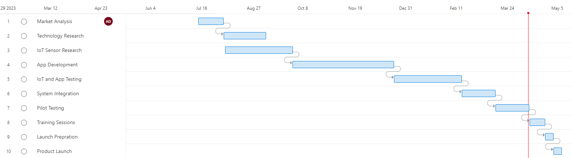

**Figure 5: SAMS Gantt Chart**

**3. EXECUTION**

**During the execution phase, the SAMS project witnesses significant progress in** **machine learning (ML) model & web app development alongside sensor deployment &** **hardware setup. ML algorithms are finely tuned to analyze sensor data for predictive** **insights, complemented by the development of a user-friendly web interface. This** **phase also sees meticulous sensor deployment, ensuring precise data collection, and** **robust hardware setup to support the system architecture. Key Performance Indicators** **(KPIs) such as data accuracy, system reliability, and user satisfaction are closely** **monitored to ensure project alignment with objectives. Additionally, efforts are directed** **towards optimizing crop yield, resource efficiency, and environmental impact through** **the integration of advanced technologies.**

**Integration and testing mark another crucial aspect of the execution phase,** **emphasizing seamless data flow and interoperability between project components.** **Various testing methodologies are employed to validate system behavior and** **functionality, ensuring compliance with specified requirements. The subsequent pilot** **deployment and data collection analysis phase focuses on real-world implementation** **in rural areas, guided by KPIs including operational efficiency, pest and disease** **management, and cost savings. Collaborative efforts with regional agriculture** **organizations facilitate successful pilot deployment, paving the way for comprehensive** **data collection and analysis. Lessons learned emphasize the importance of agile** **approaches and continuous monitoring, positioning SAMS as a transformative solution** **for sustainable agriculture practices.**

**Figure 6: Key Performance Indicators (KPIs)**

**4. CLOSING PHASE**

**Demo/Training Schedule Plan**  
 The "Demo and Training Schedule Plan" lists the **dates, times, location, facilitators, status, and aggregated feedback score from the** **participants for the Smart Agriculture Monitoring System (SAMS) project's demo and** **training sessions. It is crucial to SAMS because with this, stakeholders and end users** **get direct experience and understanding of SAMS's capabilities through well-crafted** **demo sessions, which enhance user adoption.**

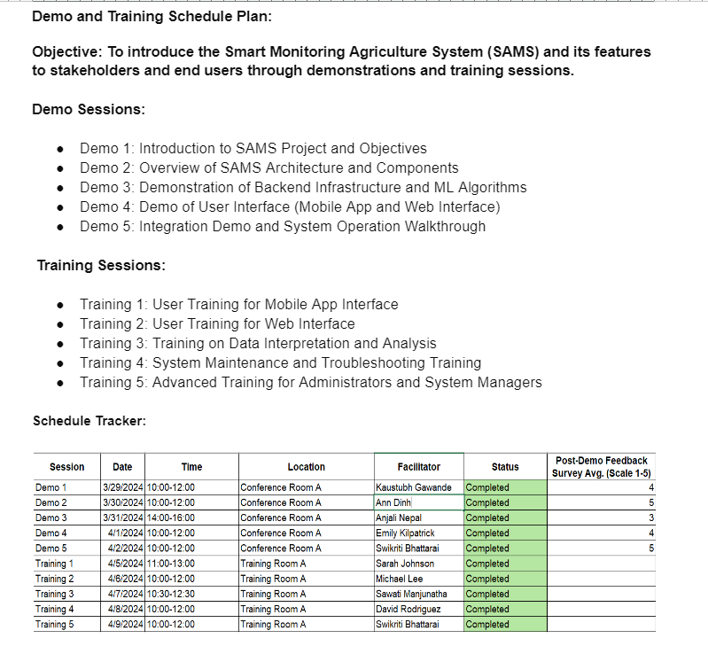

**Figure 7: Demo & Training Schedule Plan for SAMS**

**Overall, this plan leverages the advantages of SAMS for sustainable agricultural** **practices and serves as a knowledge transfer. Also, the good feedback score from** **participants indicates that the demo and training sessions for the Smart Agriculture** **Monitoring System (SAMS) were a success, as they demonstrated a clear grasp and** appreciation of the system's potential.   
  
**Project Audit Report**  
 For the SAMS project, a **project audit is necessary to make sure that the intended goals are being followed and** **to find any deviations. It enables the project team to evaluate work, deal with problems,** **and efficiently manage risks. It was discovered during the project audit that** **interdependence between the advancement of software applications and IoT sensor** **development created integration problems. As a result, some project phases saw** **slower-than-expected progress, requiring modifications to account for integration** **challenges and guarantee smooth development. Feedback from end users also** **highlighted the need for improved support and training to make the most of the SAMS** **platform. This demonstrates how crucial continuing user support and involvement are** **to promoting effective technology adoption. In the future, enhancing project efficiency** **and attaining desired outcomes for SAMS will need addressing integration** **dependencies and strengthening user support systems.**

**Maintenance and Continuous Monitoring Strategy**  
 **To maintain the functionality,** **dependability, and security of the system, the maintenance and continuous monitoring** **strategy for SAMS includes routine inspections, updates, and real-time monitoring. To** **preserve the integrity of the system components, it includes tasks like biweekly data** **backups, quarterly software updates, and monthly hardware inspections. Furthermore,** **automated error alarms and real-time monitoring are put in place to quickly detect and** **resolve any problems that might occur, guaranteeing that the SAMS platform continues** **to function. In addition, the strategy includes training sessions and user support to give** **users continuous help and direction so they can utilize the system effectively.**

**LESSONS LEARNED**  
 **Lessons for future project phases and efforts to manage** **project management efficiently are among the project's main takeaways. Within this** **project, stakeholder progress was driven by clear communication and objective** **alignment, which enabled effective stakeholder management. Agile approaches** **improved the project's responsiveness and efficiency by allowing the team to quickly** **adjust to shifting needs and market conditions. Proactive risk management techniques** **ensured seamless project execution by reducing potential disruptions. Innovation and** **problem-solving were encouraged by cooperation and teamwork, and continuous** **improvement programs established the foundation for further success. Furthermore,** **the importance of thorough integration planning was made clear, highlighting the need** **for rigorous preparation and execution to reduce delays and optimize project impact.**

**CONCLUSION**   
 **Overall, the Smart Agriculture Monitoring System (SAMS)** **implementation was successful. SAMS has transformed farming methods by utilizing** **real-time data insights. This has given farmers unparalleled access to information that** **is essential for enhancing crop management and advancing sustainability. The** **initiative demonstrated how technology may be used to address long-standing** **agricultural issues and build resilience in the face of environmental uncertainty. The** **accomplishment of project difficulties was largely attributed to collaboration, resilience,** **and adaptation, highlighting the significance of agile approaches and cooperation.** **Despite obstacles in the path, rigorous risk management and ongoing improvement** **programs made sure the project was carried out without a hitch. By bridging the gap** **between technology and farming techniques, SAMS's achievement establishes a new** **benchmark for precision agriculture and opens the door to a more sustainable future in** **the agricultural industry.**

**WORKS CITED**

**Fresno State Library. “Libguides: AGBS 120: Agribusiness Management: SWOT** **Analysis.” *AGBS 120: Agribusiness Management*, LibGuides at California State** **University Fresno,14 Feb. 2024.** [**https://guides.library.fresnostate.edu/c.php?g=289058&p=7200990**](https://guides.library.fresnostate.edu/c.php?g=289058&p=7200990)**. Accessed 18 April** 2024.